# Week 8 – Assignment 2 – Linear Programming

By: Zach Adair

Regis University

MSDS 650 – Data Analytics

## Introduction

For assignment 2 of this week I will be working through two linear programming exercises in RStudio. Linear programming is designed to optimize linear relationships based on a set of given constraints. These types of problems can be anything, like lowest cost, max profit, furthest distance, fastest run, etc. anything that will maximize the output in the desired direction of the parties involved. After running through these two exercises I will summarize what I did as well as what I learned from the exercises.

## Exercise 1

This problem is a real-world linear problem from a math class: **A farmer has 10 acres to plant in wheat and rye. He has to plant at least 7 acres. However, he has only $1200 to spend and each acre of wheat costs $200 to plant and each acre of rye cost $100 to plant. Moreover, the farmer has to get the planting done in 12 hours and it takes an hour to plant an acre of wheat and 2 hours to plant an acre of rye. If the profit is $500/acre of wheat and $300/acre of rye, how many acres of each should be planted to maximize profits?**

### Step 1: Install lpSolveAPI

Start by bringing in the lpSolveAPI package, this will give us the commands we need to optimize the farmers output.

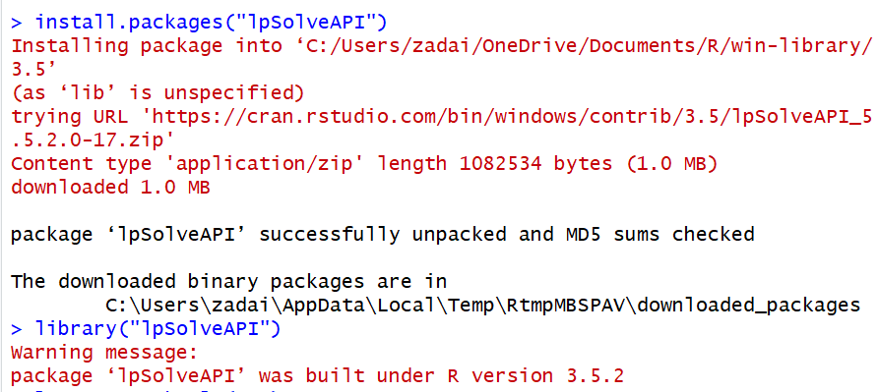

### Step 2: Set the parameters specific to the problem

Start with setting up the parameters of the crops, since there are two crops (wheat and rye) than the model needs to have 0 columns and 2 rows.



Now we will want to make sure we maximize our output, so this next parameter brings in the control which makes sure we find that maximum value.

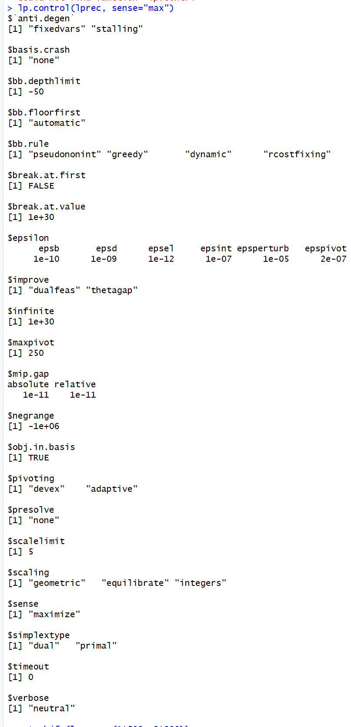

Now with our parameters set, we can add the needed constraints and find out how to optimize our farmers output.

### Step 3: Set the objective function and add constraints as needed

Start with the work hours to profit here, remember, for wheat 1 hour/$500 and for rye 2 hous/$300.



Next, set the first constraint, is per seed where $200/acre of wheat and $100/acre of rye and the budget caps us at $1,200.



Second constraint, 1 hour of labor/acre of wheat and 2 hours of labor/acre of rye.



Then final constraint, 10 acres of available land, 7 or more must be planted.



Now we just need to solve the model and see our result.

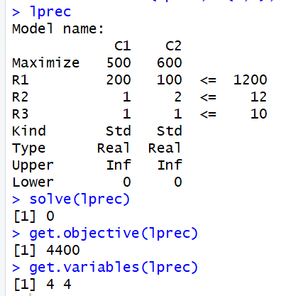

From the results of our model we know the farmer needs to plant 4 acres of both rye and wheat which will give him a maximum profit of $4,400.

## Exercise 2

In exercise 2, we have a similar problem to what we had for exercise 1. The linear problem is the following: **“A gold processor has two sources of gold ore, source A and source B. In order to keep his plant running, at least 3 tons of ore must be processed each day. Ore from source A costs $20/ton to process, and ore from source B costs $10/ton to process. Costs must be kept to less than $80/day. Moreover, Federal Regulations require that the amount of ore from source B can’t exceed twice the amount of ore from source A. If ore from source A yields 2 oz. of gold per ton, and ore from source B yields 3 oz. of gold per ton, how many tons of ore from both sources must be processed each day to max the amount of gold extracted subject to the above constraints?**

### Step 1: Install lpSolveAPI

Since I have the same Rstudio workspace open I don’t need to install the lpSolveAPI package. Lucky Me!

### Step 2: Set the parameters specific to the problem

Like exercise 1, we will create a model with zero rows and two columns.



Next, we will create our maximum parameter to find the max amount of ore we need to take out of each source

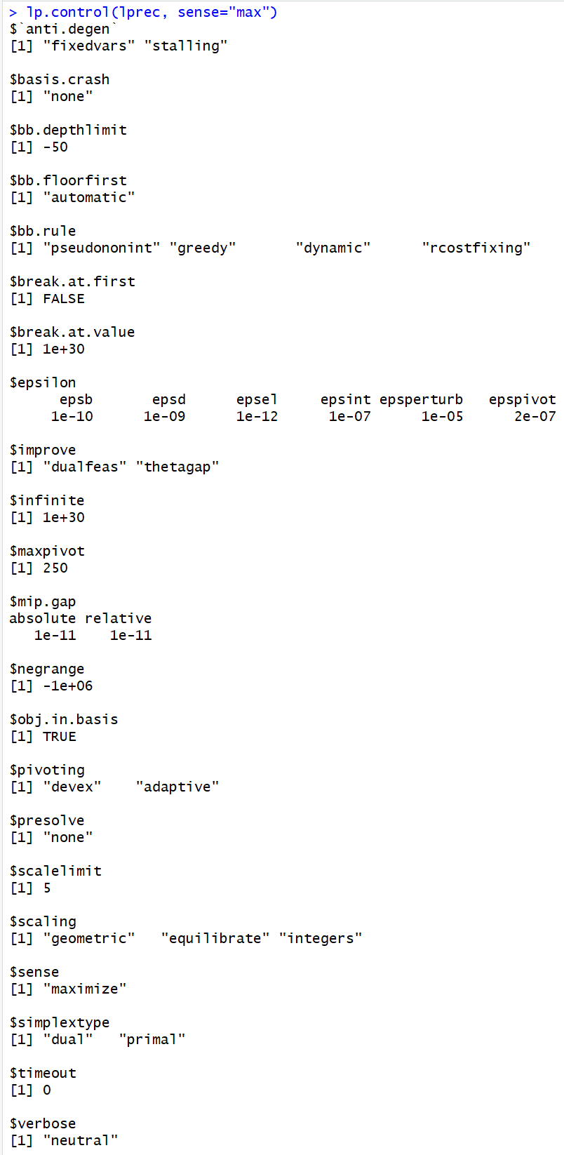

### Step 3: Set the objective function and add constraints as needed

Now is time to set the constraints, since source one yields 2 oz. gold/ton and source two yields 3 oz. gold/ton we will need to set our parameters as such.



Next, add the constraints for the costs, source one costs $20/ton to process and source two costs $30/ton to process and costs can’t exceed $80/day.



The last constraint is that the ore from source two can’t be 2 times the amount of ore from source one.



Now it’s time to plot the model and find our result.

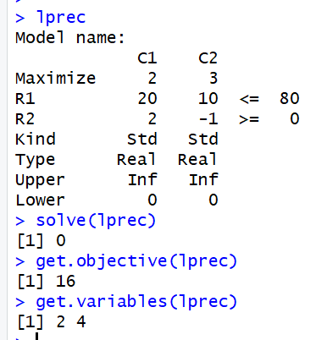

As a result, if the company processes 2 tons of ore/day from source one and 4 tons of ore/day from source two then the max profit they would yield is 16 oz.

## Summary

From the two exercises for week 8 I really felt like I learned a lot about linear programming. The examples were very apparent with their steps so it didn’t take much to recognize each step and what needed to be done. I found myself thinking back to old real-world problems I would get in algebra class which are very relatable to these exercises and thinking about how nice it would be to have had RStudio to help me solve those! What I also thought about is how useful this model can be for different types of problems in the real world, if I know the factors for a business I’m trying to start and I’m trying to find my break even point I can do that, or if I want to find the work that would need to be done I could play around with this kind of model and figure out the max profits my company would be set to make. This was a good introduction into the topic overall, I think as I get further along in my data science journey I believe I will be using this more and more because it just seems so applicable to many problems I would like to try to solve.